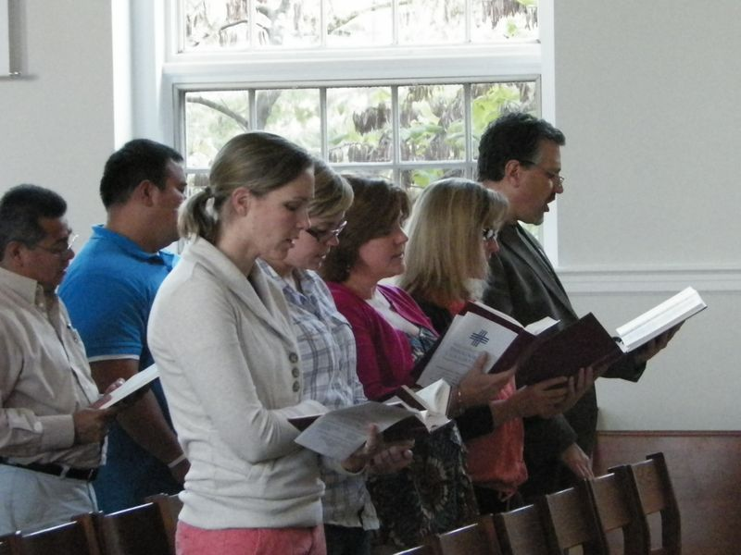  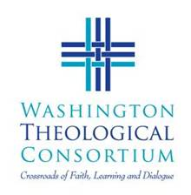 | New Student Orientation and Ecumenical Prayer Service  Washington Theological Consortium  Orientation by Dr. Larry Golemon (Executive Director) and Service by Consortium Student Board &  Seminary Choir (TBA)  Thursday, September 12, 4:30-8:30 pm  St. Vincent de Paul’s Chapel,  Catholic University (near Law School)  620 Michigan Ave. NE, Washington DC  Followed by Dinner and Conversation at  Various Religious Houses  (Dominican, Paulist, Benedictine,  Franciscan, Sulpician, and more)  Reservations Important for our Hosts!!  (see your Dean, or contact wtc@washtheocon.org )  