Ecumenism Award Worship for Christian Unity and Figel Address | 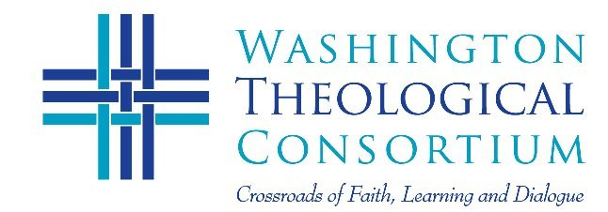
Thursday, February 9  6:00-9:00 pm  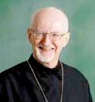  Fr. John Erickson  Reception follows. No charge for this event thanks to a sustaining gift from Jack Figel | You are Invited to this Annual Event  Prayer Service for Christian Unity, WTC Ecumenism Award, and the 9th Annual Figel Address on Ecumenism  “What Divides, What Unites?  Shifting Perceptions in Ecumenical Relations”  Rev. Dr. John Erickson, Professor Emeritus and former Dean  St. Vladimir’s Orthodox Theological Seminary  Venue: Ukrainian Catholic National Shrine of the Holy Family  4250 Harewood Road NE, Washington, DC (near CUA)  Fr. John Erickson brings years of experience in Ecumenism and teaching in Eastern Orthodox theological studies to reflect on the shifting terrain of what unites and divides in the quest for Christian Unity. While he will focus on the relations between the Eastern Orthodox and the Roman Catholic Church, he will identify the issues of unity and division in terms that apply to all Christian communities and individuals who care deeply about Church Unity.
Please RSVP by February 7 to wtc@washtheocon.org or call 202-832-2675

415 Michigan Ave. NE, Suite 105
Washington DC, 20017

Fr. John Erickson brings years of experience in Ecumenism and teaching in Eastern Orthodox theological studies to reflect on the shifting terrain of what unites and divides in the quest for Christian Unity. While he will focus on the relations between the Eastern Orthodox and the Roman Catholic Church, he will identify the issues of unity and division in terms that apply to all Christian communities and individuals who care deeply about Church Unity.

Visit: http://washtheocon.org/events/

