Welcome to New Students
Ecumenical Service and Dinners
September 17, 2015

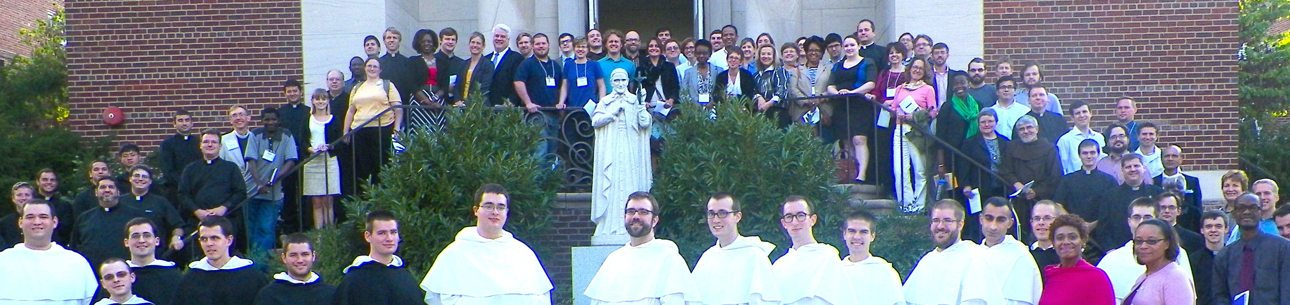
Students after Prayer Service 2014
Thursday, September 17  4:30-8:30 pm  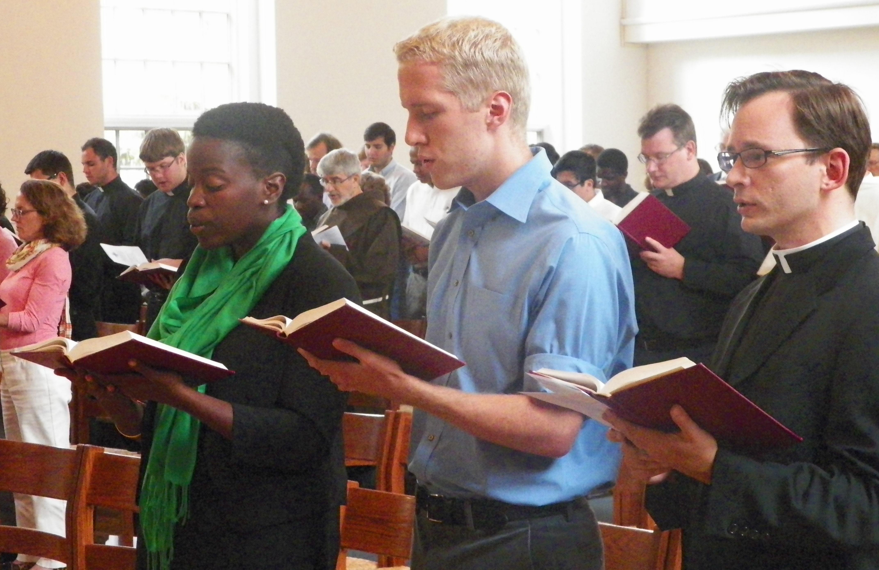  Student Leaders at Prayer Service  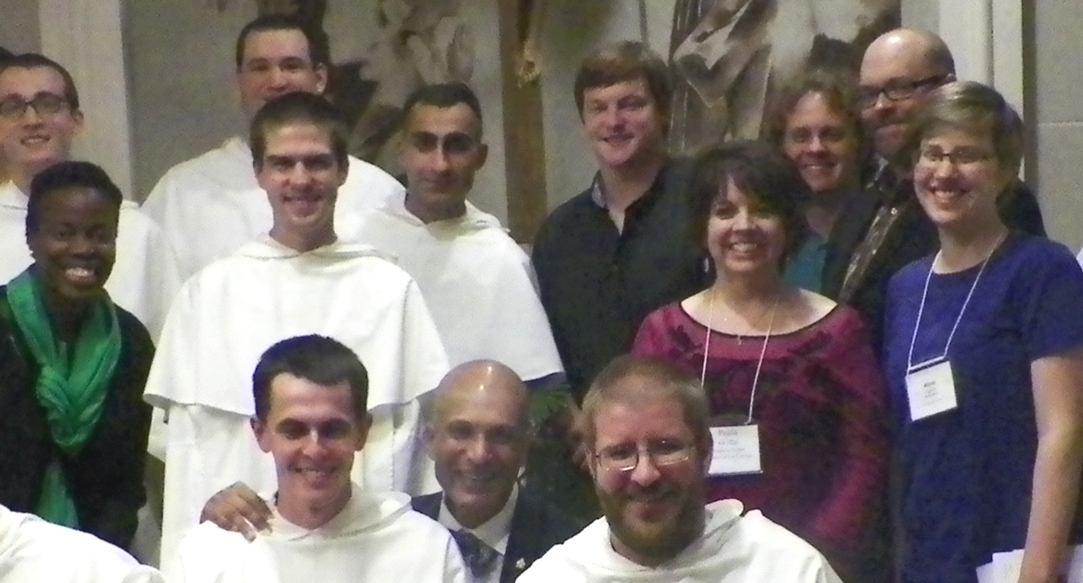  Students Visit Dominican House | New Student Prayer Service and Orientation  “Connecting Through Prayer and Fellowship”  Catholic University: St. Vincent DePaul’s Chapel  (John McCormack Rd off of 620 Michigan Ave NE)  Service lead by the Consortium Student Board  Orientation by Dr. Larry Golemon, Director  Dinner and Conversation Follow at Religious Houses  (Dominicans, Paulists, Benedictines, Franciscans, Carmelites, and more welcome us.)  RSVP with your Dean or to WTC below to help  these communities plan for dinner.
RSVP with your Dean or contact wtc@washtheocon.org or call 202-832-2675

