WTC Faculties’ Convocation  Monday, October 2  6:00-9:00 pm  (Registration from 5:30)  Sponsored by the Council of Deans | 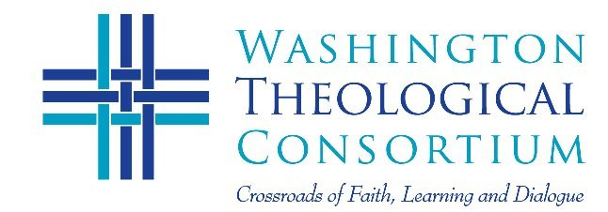
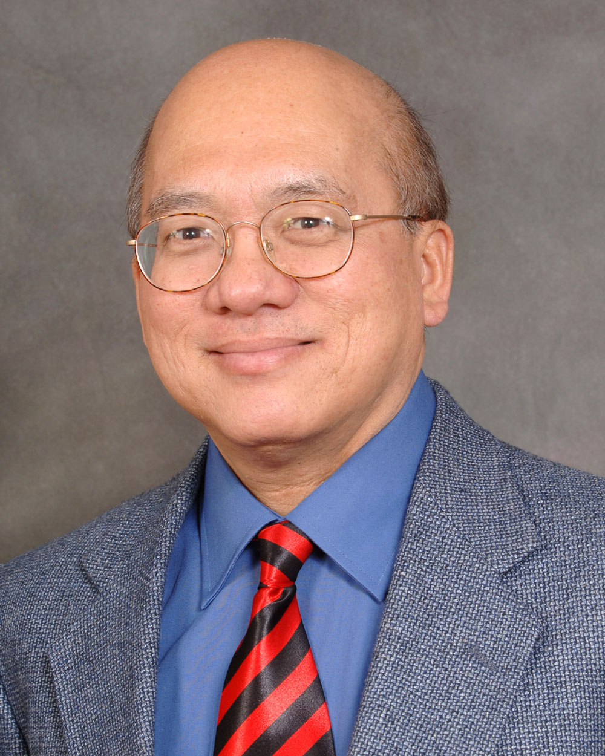  Dr. Peter C. Phan  Georgetown University  Peter Phan, a native of Vietnam, emigrated as a refugee to the U.S.A. in 1975. He earned the Doctor of Sacred Theology from the Universitas Pontificia Salesiana, Rome, and the Doctor of Philosophy and the Doctor of Divinity from the University of London. He has taught at the University of Dallas; at the Catholic University of America, at Union Theological Seminary (New York), at Elms College, (Chicopee, MA), at St. Norbert College (De Pere, WI), and at Georgetown University, where he holds the Ignacio Ellacuría Chair of Catholic Social Thought. He has served as President of the Catholic Theological Society of America, and he received the CTSA’s John Courtney Murray Award in 2010.  His publications range from the theology of the icon and patristic thought to ecclesiology, mission, and culture. Dr. Phan has addressed issues of ecclesial diversity and immigration in Many Faces, One Church; Cultural Diversity and the American Catholic Experience (Rowman and Littlefield, 2005), Contemporary Issues of Migration and Theology (2013, MacMillan), and Christianities in Migration: The Global Perspective (Springer, 2016). He is general editor of the multi-volume series Theology in Global Perspective (Orbis) and Ethnic American Pastoral Spirituality (Paulist). His work has been published in eleven languages. | 45th Annual Faculties’ Convocation  Washington Theological Consortium  “No Longer Strangers and Foreigners:”  The Intersection of Christian Identity,  Mission, and the Ethics of Immigration  Dr. Peter C. Phan,  Ellacuria Chair of Catholic Social Thought,  Georgetown University  Presentation, Panel and Discussion,  Faculty Groups and Full Reception  New York Avenue Presbyterian Church,  1313 New York Ave. NW, Washington DC  NYAPC is an active member of the Sanctuary Network of Churches in Washington, D.C., dedicated to the advocacy for and support of immigrants throughout the region.  Metro access: from Metro Center stop (Orange, Red and Blue lines). Parking garage available at 1399 New York Avenue, next to church.  Come, Join your colleagues for this inspiring evening!  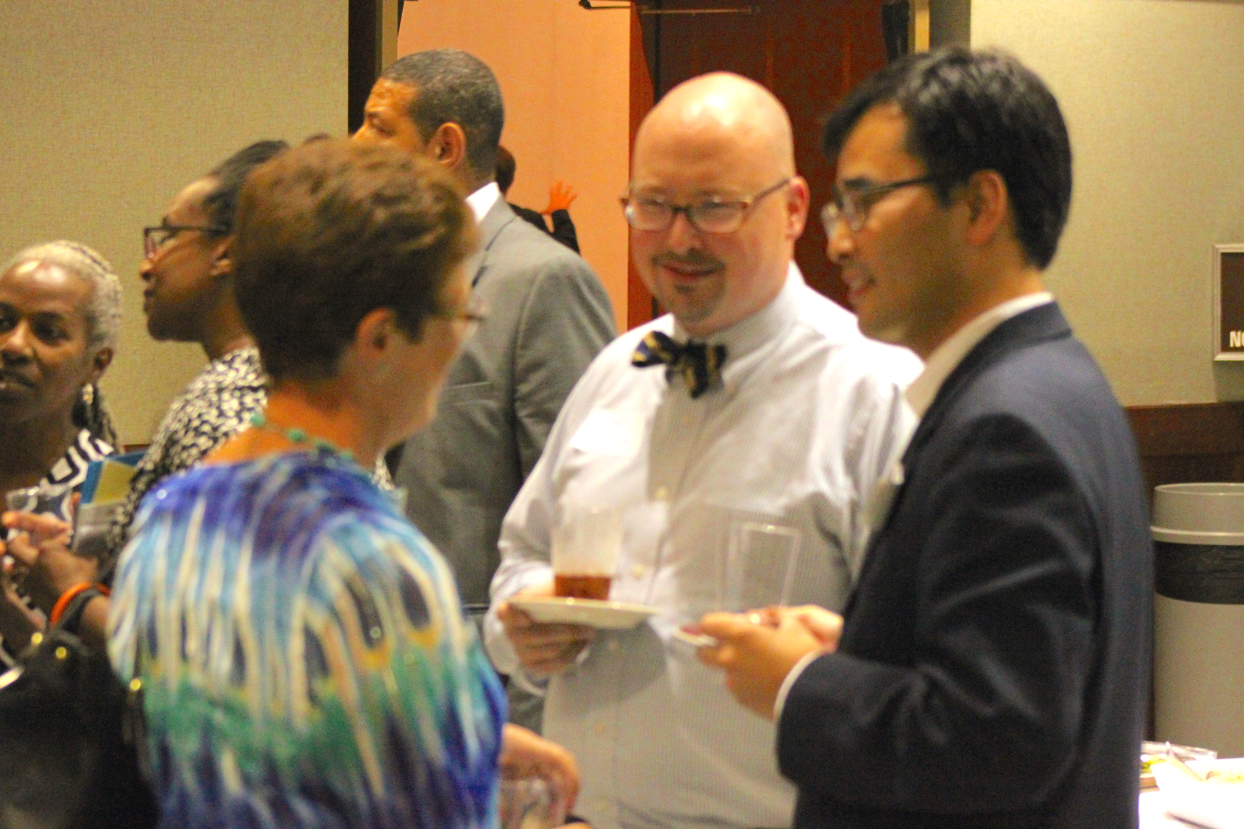
RSVP with your Academic Dean or contact wtc@washtheocon.org (202-832-2675)

