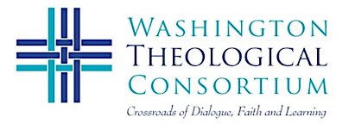 |  | 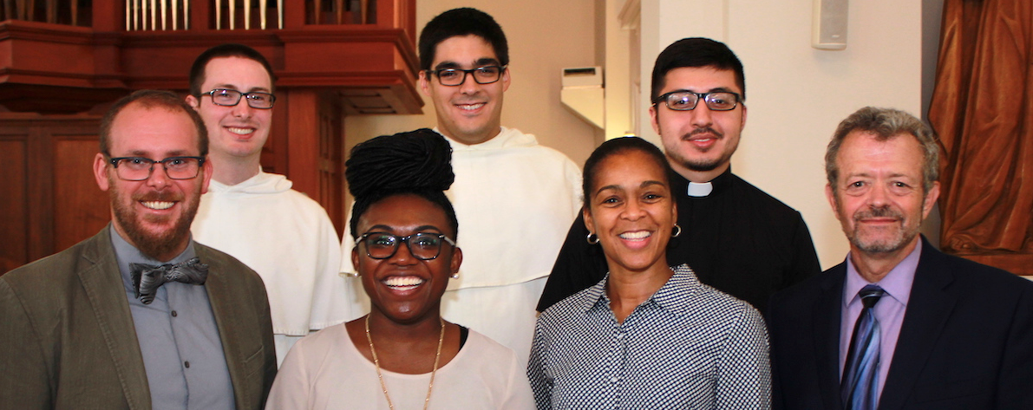  Student Board Members and Dr. Golemon at Prayer Service
CONSORTIUM EVENTS Fall 2019
RSVP to wtc@washtheocon.org

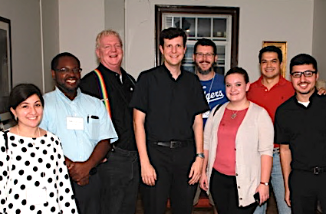  Students at Paulist House | OPENING STUDENT PRAYER SERVICE, Orientation, and Dinners at Religious Houses. Thursday, September 12  Catholic University, St. Vincent Chapel (John McCormack Road)  4:30 pm—Orientation and Ecumenical Prayer Service  6:00 pm—Dinner and Student Conversations with Dominicans, Paulists, Carmelites, Franciscans, Benedictines, TC and more!  8:30 pm—Return to CUA, St. Vincent’s Chapel
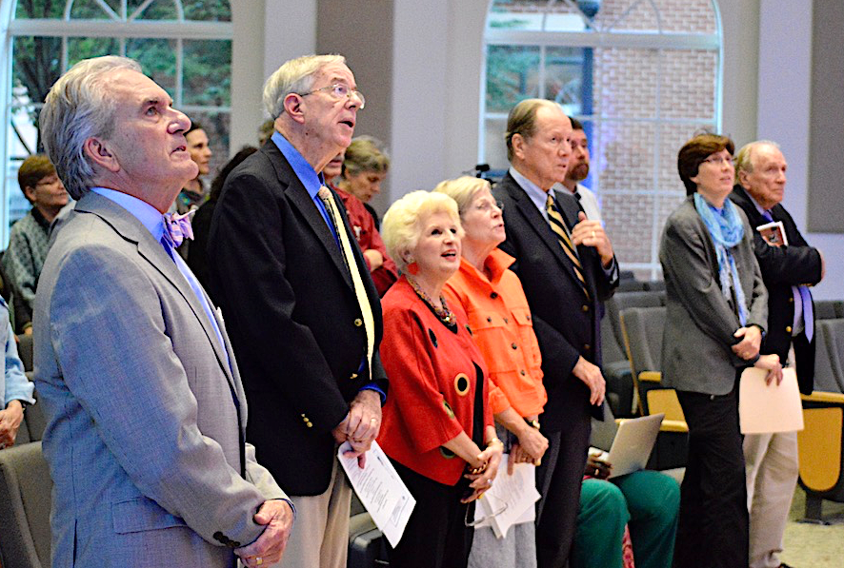  Faculty at Convocation | ANNUAL FACULTIES CONVOCATION, MONDAY SEPTEMBER 23  PFIC, Dominican House of Studies, 485 Michigan Ave. NE, DC  “The Role of Faith in Theological Education”  4:30—Registration and Refreshments  5:00—Opening Prayer Service  5:30—Faculty Panel (from WTC schools) and Discussion  7:00—Faculty Interest Groups Plan for the Year  7:30—Full Reception
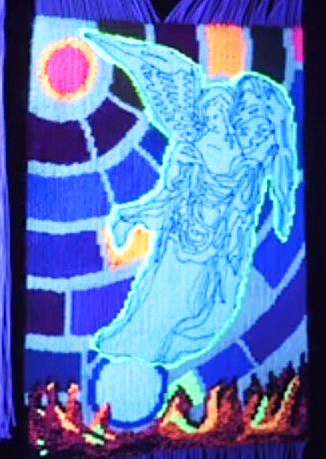  Copyright Dr. Barbieri | “REVELATION TODAY: The Apocalypse in the Bible and Contemporary Art” OCTOBER 10, 7:00-9:00 pm (pre-tour 6:00)  Museum of the Bible, 400 4th Street SE, Washington, DC  Expert Faculty Discussion on Apocalyptic visions for today.  Dr. Stephen Cook, Virginia Theological Seminary (Hebrew Bible)  Dr. Ben Witherington, Asbury Theological Seminary (New Testament)  Dr. Deborah Sokolove, Wesley Theological Seminary (Art & Religion)  Dr. Denise Dombkowski Hopkins, Wesley, Moderating  Includes Reception and Faculty/Student Artist Exhibit  Fee for Public, no cost for WTC member students, faculty, and staff  At 6:00 pm there is an optional curated tour of the special exhibit.  “The Tapestry of Light,” by Dr. Irene Barbieri (reduced fee for WTC)
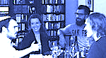  Matthew, Allison, friend, and Derek | “THE POWER OF COMMUNITY: The Journey of a Former  White Supremacist.” Sunday, November 3, 4:00-7:00 pm  Annual Tachmindji Event for Peacemaking and Interfaith  at American University (School of International Service)  Three young professionals share their dramatic story of friendship and change with a former youth leader in the white supremacy movement. Panel: Matthew Stevenson, Allison Gornik, and R. Derek Black. Moderator: Dr. Marc Gopin, George Mason University, Center of World Religions, Diplomacy and Conflict Resolution. Advance RSVP is required.
Event details at https://washtheocon.org/events RSVP to wtc@washtheocon.org or call 202-832-2675

