The Washington Theological Consortium
Student Board presents:

"Ministry in the Media:
Who Do They Say That I Am?"
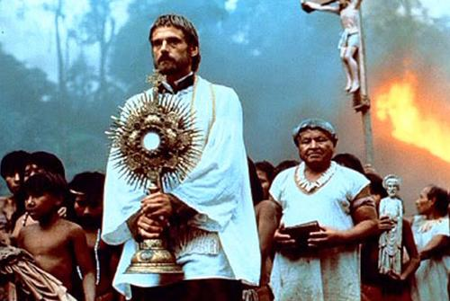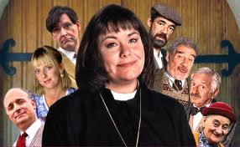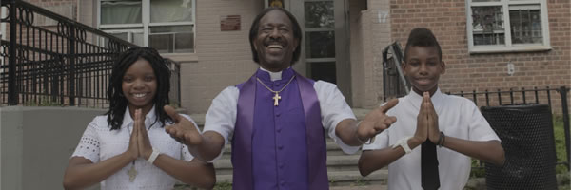
7-10 pm Monday, November 25th, 2013

Join students from across the Consortium for an evening of conversation and socializing

Presentations and Discussions with:

The Rev Dr Justin Lewis-Anthony
Associate Dean of Students
(Virginia Theological Seminary)

Fr. John D. Corbett, OP
Assistant Professor of Moral Theology
(Pontifical Faculty of the Immaculate Conception at the Dominican House of Studies)

“Café 1823” @ Virginia Theological Seminary
in the Refectory, near Scott Lounge
3737 Seminary Road; Alexandria, VA 22304

