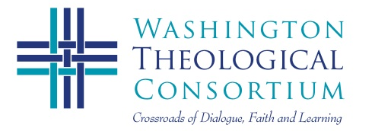 | Events 2013-14

September 12, 2013 (Thur)  4:30-8:30 p.m.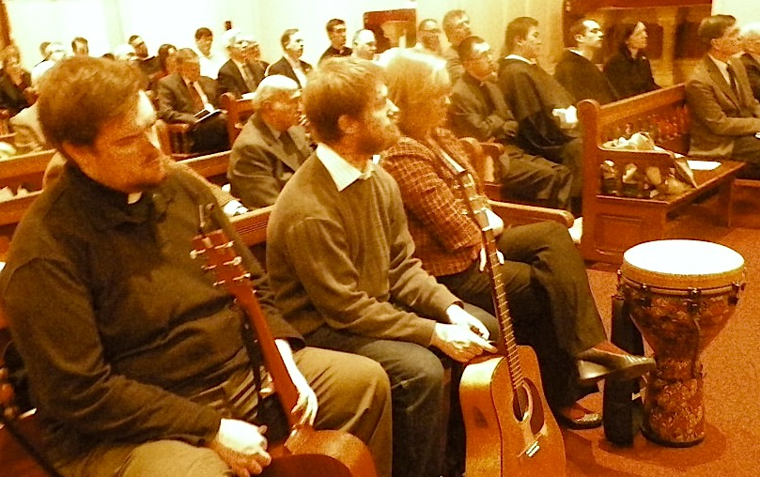 | New Student Prayer Service and Orientation  Consortium Student Board & Seminary Choir (TBA)  St. Vincent de Paul’s Chapel, Catholic University  620 Michigan Ave. NE, Washington DC  Followed by Dinner and Conversation at Religious Houses  Reservations Encouraged (see your Dean)
September 21, 2013 (Sat)  9:30am-1:30 p.m.  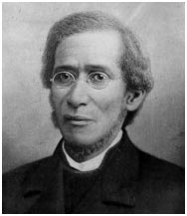 | 41st Annual Faculties’ Convocation:  Reframing the Civil War: Religion, Race & Culture New Seminary Ridge Museum Staff  Gettysburg and Howard Faculty  Lutheran Theological Seminary at Gettysburg  61 Seminary Rdige, Gettysburg, PS  Faculty Groups and Luncheon
October 20, 2013 (Sun)  5:30-3:30 p.m.  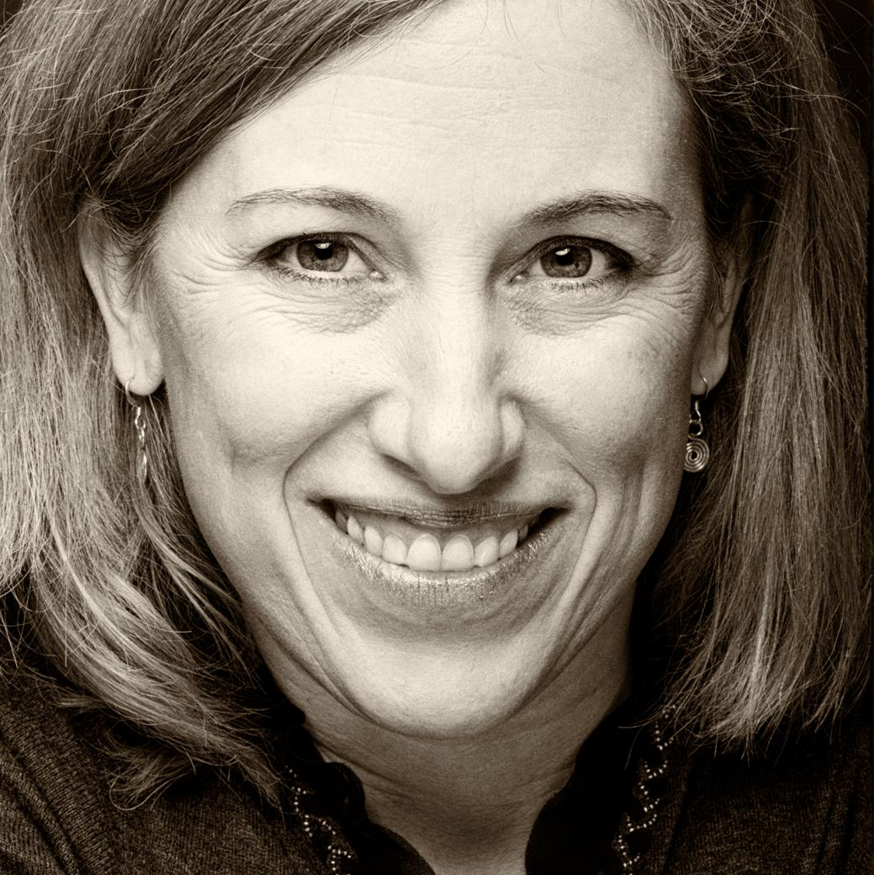 | Annual Tachmindji Event: Religion & Peace  in International Conflicts  Dr. Lisa Schirch, Eastern Mennonite University  Center for Justice and Peacebuilding  School of International Service,  American University, Washington DC  Presentation, Discussion, and Buffet
February 6, 2013 (Thur)  5:00-7:00 p.m.  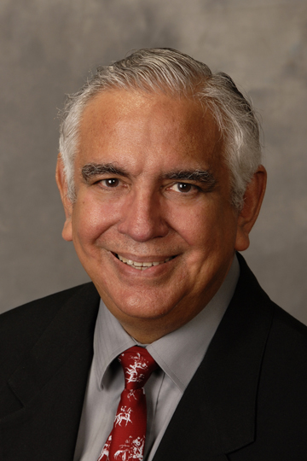 | Worship Service for Week of Prayer for Christian Unity  Ecumenism Award, and Figel Address  Dr.Justo Gonzalez, founder Hispanic Theological Initiative  Church Historian and Theologian  Wesley Theological Seminary  4500 Massachusetts Ave NW, Washington DC  Reception Follows
February 28, 2013 (Thur)  5:30-8:30 p.m.  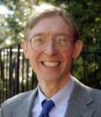 | Al-Alwani Lectures: Who are the “People of the Book”?  Dr. Richard Jones, Washington Theological Consortium  and Guest Muslim Scholar (TBA)  El-Hibri Charitable Foundation, 1420 16th St. NW, D.C.  Full Reception Follows

