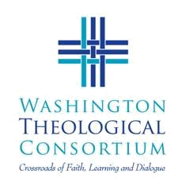
Washington Theological Consortium

Library Borrowing Privileges Form

This form is to be filled out by the Circulation Services Librarian (or proxy) at the student’s or faculty’s home institution BEFORE they can borrow books from another WTC institution. This form and appropriate photo ID MUST be presented (first time only) when borrowing material from another library. For eligible WTC libraries only (list below).

Student Name __________________________________________________

Institution _____________________________________________________

Student Number (if applicable) ____________________________________

Degree Program & Graduation Date ________________________________

Valid for semester_______________ until (MM/DD/YY) ______________

Home Librarian (name) _________________________________________

(signature) _______________________________________

Participating Institutions

The Catholic University of America  Northeast DC | Reformed Theological Seminary, DC  McLean, VA
The Graduate School of Islamic  and Social Sciences, Herndon, VA | Samuel Dewitt Proctor School of Theology  at Virginia Union University  Richmond, VA
Howard University School of Divinity  Northeast DC (Div School only) | Virginia Theological Seminary  Alexandria, VA
The John Leland Center for  Theological Studies | Wesley Theological Seminary  Northwest DC
Lutheran Theological Seminary  at Gettysburg (PA) | Woodstock Theological Center  Georgetown University

Library information and directions at http://washtheocon.org or 202-832-2675

