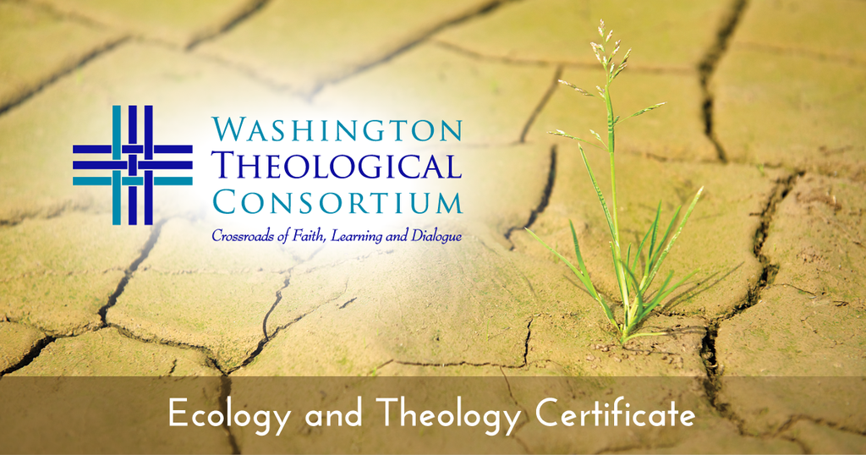
FAQ about the Certificate in Ecology and Theology

What is the “Certificate in Ecology & Theology?”

A study option through the Washington Theological Consortium, an ecumenical and inter-faith team of theological schools including Gettysburg Seminary. The Certificate is 4 courses or a total of 12 credits.

Why study Theology and Ecology?

- Environmental problems challenge global society. Religious traditions have extensive influence among individuals, local communities and across borders. Pope Francis, Patriarch Bartholomew, the Lutheran World Federation and many other church leaders have called upon the church to care for God’s world and help prevent further damage.
- Theological Insight & Powerful Teaching emerge from critical re-consideration of past religious traditions and the search for effective ways to help the world overcome environmental problems. New depths of connection to God, one another and God’s community of earth beckon beyond and through the challenges at hand.

How do I earn a Certificate in Theology & Ecology?

Choose from a variety of options in the Washington Theological Consortium in the following areas:

- Religious Heritage in Ecological Perspective (courses such as: Ecological Hermeneutics and Scripture, History of Religious Thought and the Natural Environment, Theology and the Natural World, Theological Anthropology in an Ecological Perspective, Development of Ecological Ethics in Religious Thought, Interfaith approaches to Ecological issues);

- Ecology and Religion in Socio-Cultural Context (courses such as: Ecology and Religion in the Arts, Social Scientific Perspectives on Religion and Ecology, Religion and Nature in the Natural Sciences, Cultural Immersion and Experiential courses with an Environmental Focus);

- Capacity for Ministerial and Public Leadership for Ecological Integrity (any courses that address ecological issues in leadership, ministerial practices (worship, preaching, etc.), spiritual life, religious education, political community, ecclesial community and practica in supervised ministry that have a strong focus on environmental issues).

- An Elective related to Ecological Studies (listed course, outside qualifying course, reading course, field ed. project, etc.)
Check into the offerings for the coming year!

More questions or possibly interested?

Contact Certificate Coordinator: Dr. Joe Bush, Wesley Theological Seminary
jbush@wesleyseminary.edu 202 885-6482

CET Offerings in 2015-2016! Also visit: Ecology and Theology Certificate WTC

Fall Semester, 2015

Wesley Theological Seminary
PW-316-0 Liturgics Practicum: Ecology and Seasons of Christian Worship. (2 credits)
Instructor: Joseph E. Bush, Professor of Practice in Ministry and Mission. Mondays, 5:30PM - 7:30PM
Curricular area: Capacity for Ministerial and Public Leadership for Ecological Integrity

Jan. Term 2016

Virginia Theological Seminary
STH xxx Theology and Science (1.5 credits). Jan 11-15 2016 (8:30-11:30 am)
Instructor: The Rt Rev Professor Richard Cheetham, Bishop of Kingston in London, UK
Curricular area: Ecology and Religion in Socio-Cultural Context

Spring Semester 2016

Howard University School of Divinity Note: Now located at Van Ness Metro Stop (Convenient to G-burg!)
BSNT xxx The Bible and the Earth
Instructor: Michael Willett Newheart, Professor of New Testament Language and Literature
Curricular area: Religious Heritage in Ecological Perspective

Gettysburg Seminary
3.103 Ecology and Stewardship--action/reflection learning in sustainability practices for churches, from food & faith to energy stewardship to public witness for eco-justice. (3 credits)
Instructor: Gilson Waldkoenig, Professor of Church in Society
Curricular area: Capacity for Ministerial and Public Leadership for Ecological Integrity

Gettysburg Seminary
6.316 OL Ecological Ethics & Faith (3 credits)
Course instructors: Gilson Waldkoenig, Professor of Church in Society, Gettysburg Seminary
Chad Rimmer, Theological Advisor to the Evangelical Church in Senegal.
Curricular area: Religious Heritage in Ecological Perspective

Wesley Theological Seminary
CM-138-0 Greening Your Congregation (2 credits)
Instructor: Elizabeth Jean Norcross. Wednesday 3:30PM - 5:30PM
Curricular area: Capacity for Ministerial and Public Leadership for Ecological Integrity

Summer 2016

Gettysburg Seminary
3.875 Environment & Religion in Northern Appalachia (3 credits).
June 12-17, 2016 immersion experience in western PA (https://vimeo.com/91113288) plus online work
Instructor: Gilson Waldkoenig, Professor of Church in Society
Curricular area: Ecology and Religion in Socio-Cultural Context

Wesley Theological Seminary
CF206 – Spirituality in Nature (2 credits)
Instructor: Elizabeth Jean Norcross (Dates to be determined)
Curricular area: Capacity for Ministerial and Public Leadership for Ecological Integrity

