Consortium  Public Events  Spring 2016  Ecumenical and Interfaith | 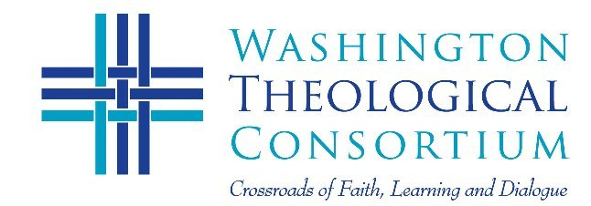
Thursday, February 11  5:30-8:30 pm  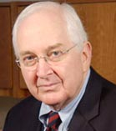 | Service for Christian Unity and 8th Annual Figel Address  The Body Lies Bleeding: The Reformation  and Contemporary Ecclesial Divisions  Dr. Joseph Small  Center for Catholic and Evangelical Theology  Former Director, Office of Theology and Worship, PCUSA  Venue: John Leland Center for Theological Studies  1306 N. Highland Street, Arlington, VA  Prayer Service, Award, Lecture and Full Reception
Tuesday March 8, 2016  6:00-9:00 pm  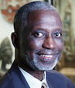 | Sixth Taha Al-Alwani Lectures on Muslim-Christian Dialogue:  African Nationalism and its Impact on Interfaith Dialogue  Dr. Sulayman Nyang  Professor of African Studies, Howard University  Venue: Howard University School of Divinity  2900 Van Ness Street, NW Washington, DC  Lectures, Discussion, Full Reception
Tuesday, April 19, 2016  6:30-8:30 pm  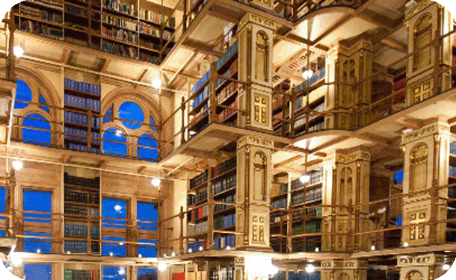 | Annual Reception for Friends’ of the Consortium  Riggs Library, Georgetown University  John Borrelli and Gerard Mannion Welcome  Discussion, tour, full reception  For more information, visit: WTC Events
To RSVP contact wtc@washtheocon.org or call 202-832-2675

