November 20, 2020
Dear Friends and Colleagues,

One thing this turbulent year has done is to clarify my priorities. Having lost a loved one, hearing of colleagues afflicted with COVID-19, seeing neighbors lose their jobs, watching friends that still struggle in the face of racism, and witnessing my favorite churches, museums and fall festivals go virtual has made me stop and think, “What is most important at a time like this?”

One word comes to mind: gratitude… for friends and colleagues, for faith, for meaningful work, for family, and for good books. Out of gratitude, I have promised to continue giving: to educational institutions, faith communities, and services for those without. One of my favorite theologians Dietrich Bonhoeffer wrote, “It is only with gratitude that life becomes rich,” and we might add, “that we make other lives richer.”

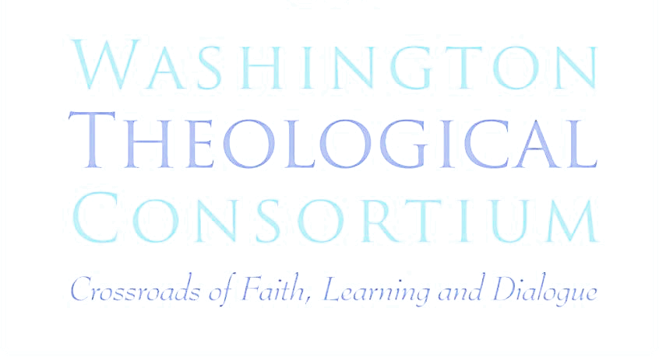
I know you get a boat-load of appeals this time of year, but I ask you to give just a bit more to the unique work of the Consortium: to students who are studying for ministry and the priesthood, to faculty who work for little to teach students a lot, and to ecumenical encounters that broaden their awareness of the whole Church and its mission of witness and reconciliation.

This theological Consortium is one of the oldest in the nation (50 years in 2021!), and one of the most vibrant. We continue to develop new programs for students, faculty, and the public that build bridges in these times of troubled waters, and that strengthen dialogue in the face of growing division. When we work together, faith leaders can inspire all of us to do our part to heal the world.

Every dollar you can give will go entirely toward new and expanded programs and courses in ecumenism, interfaith dialogue, ecology and ministry, and criminal justice and reconciliation. Our overhead is already covered, so this is a sound investment indeed!

Just last week, we held a Sermon Slam with eight student preachers from as many schools, and they illustrated once again a bright future for the Church. In February, Fr. John Crossin, OSFS will receive our Ecumenism Award and offer his vision - past, present and future - about the prospects for Christian unity and common witness. Our creative work continues, but only with your help.

In these uncertain times of reckoning, loss and change I invite you to join us in spreading gratitude and hope. I ask you to pray for our work, and to actively support us with a gift so that new religious leaders will emerge with cultivated minds, thankful hearts, and a mission to give of themselves.

Always grateful,  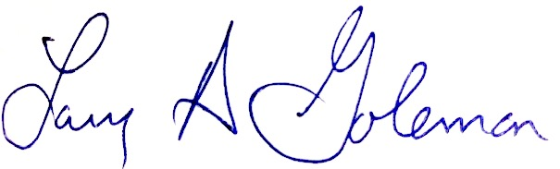  Rev. Larry Golemon, PhD  Executive Director | You may give via check in the enclosed envelope or online at: https://washtheocon.org/donate

