Presentation: "Objects of Devotion: Religion in America at the Smithsonian"
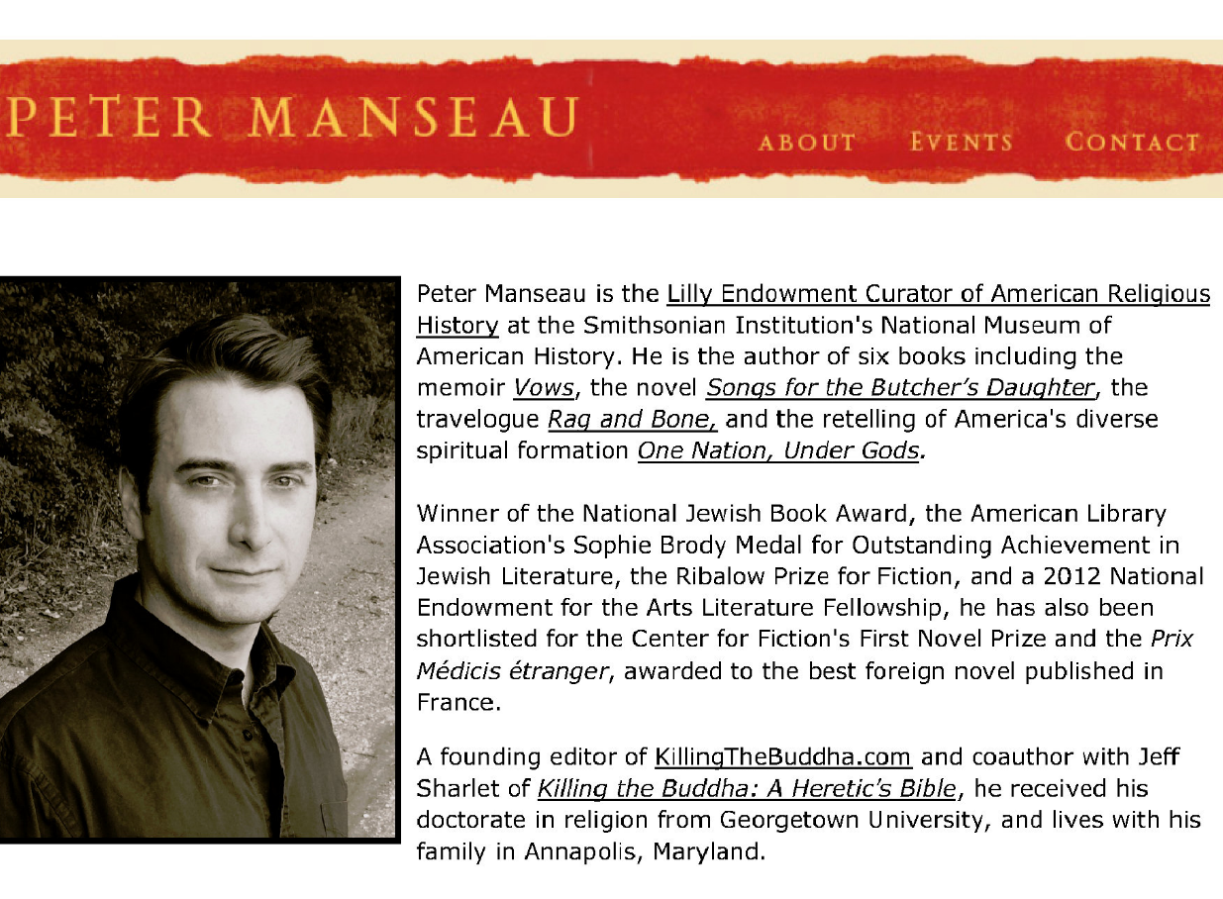
RSVP: wtc@washtheocon.org or call 202-832-2675
No charge, optional lunch at restaurant will be covered. Parking can be reimbursed.
Thanks to Dr. Mitzi Budde and the WTC Librarians for opening this event to all faculties!

