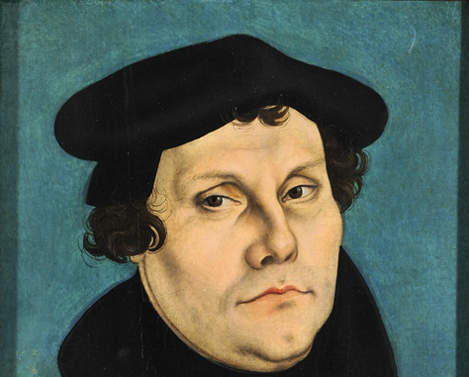

NovEMBER 6-7, 2015
symposium Begin Friday 5:00pm
marking the 500th Anniversary of the protestant Reformation

The Forgotten Luther: Advocate For The Poor
Hear from prominent scholars about the work of Luther and other reformers to end economic exploitation and advocate for the common good.

Director of Music, Paul Leavitt, will lead the Reformation Choir in singing his original composition, “Luther’s Words” at the Friday reception.
With financial support from the Metropolitan Washington DC Synod, Thrivent Financial, ELCA World Hunger Education Program, Church of the Reformation, Embassy of the Federal Republic of Germany, & Individual Donors
(Details on reverse side)
Speakers
Carter Lindberg, PhD
Author: Beyond Charity:
Reformation Initiatives for the Poor
Cynthia Moe-Lobeda, PhD
Author: Resisting Structural Evil:
Love as Ecological-Economic Vocation
Samuel Torvend, PhD
Author: Luther and the Hungry Poor: Gathered Fragments
Jon Pahl, PhD
Author: Empire of Sacrifice: The Religious Origins
of American Violence
Gordon “Tim” Huffman, PhD
Author: The Lutheran Confessions: A Digital Anthology

Location of Symposium: Church of the Reformation
212 E Capitol Street
Washington, DC 20003
Register Online: http://www.eventbrite.com/e/forgotten-luther-symposium-tickets-17174017950

Or send a check to ‘Church of the Reformation’ (memo line: ‘Forgotten Luther’)
Cost: $60 (includes dinner); $15 students
No one will be excluded

Nov 6, 5 pm: Reception, Choral Offering Dinner & Keynote
Nov 7: 8:30am-12:30pm

