Theological Consortium, Sample Auction Items for April 19, 2016

Framed “Our Father,” Lord’s Prayer in Arabic
Wonderful black and silver metallic textured artwork from Middle East with contemporary black block-style frame.

Value: $200 Opening Bid: $75
______________________________________

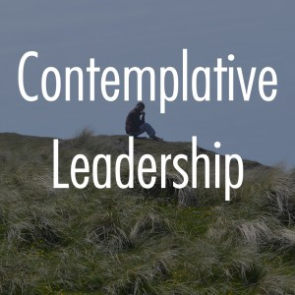
Contemplative Leadership Seminar—Online, Shalem Institute
Available May 4 through May 25, 2016

Do you yearn to explore a way of leading that is more aligned with your heart? Shalem’s groundbreaking online seminar invites you to join other leaders as we reflect on the invitation to contemplative leadership, a countercultural practice grounded in deep listening and compassion. Whether you are in a formal or informal leadership role, you’ll find practices and support to help you remain spacious, flexible and open to the True Leader, the Spirit.
Value: $150 Opening Bid: $75
______________________________________

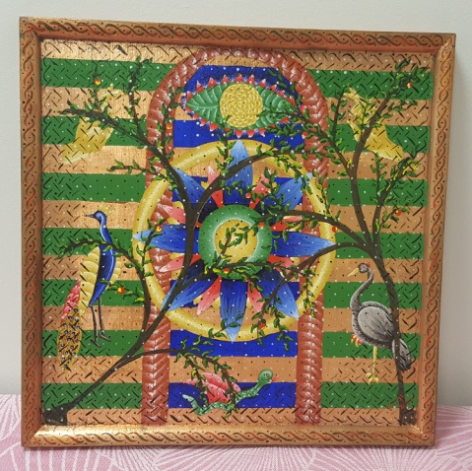
Sokolove Painting – “Finding Direction” Hand-painted, wooden frame.

Statement from the D.C. painter, Deborah Sokolove: “As an analogue to my belief that every time and place participates in God’s self-revelation, I combine elements from the icon tradition of the Eastern branches of Christianity; the elaborate knot work found in Celtic artifacts; the space-filling patterns of Islamic tiles; folk motifs from Latin America, Africa, and Asia; and contemporary notions about art. The resulting paintings are intended as an offering into the life of the Body of Christ, my own prayers made visible as an invitation to others.”
Value: $700 Opening Bid: $125
________________________________________________

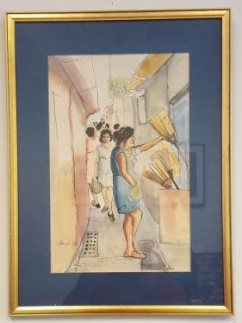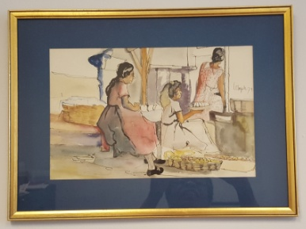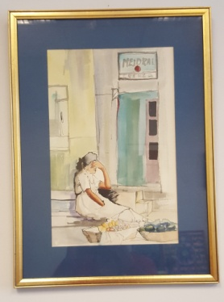
Collection of 3 Gold-Framed Paintings by El Aleph

Three remarkable early-career watercolors by renowned Salvadoran painter, Jose Alex Chavez Sanchez, aka ‘El Aleph”. Reflecting somewhere between thematic and indigenous roots; with nature in the way that is surrounds us, the works are related to the themes of the Salvadorian countryside. Sanchez has had 25 solo exhibitions and 65 collective exhibitions in the United States, Central America, Malaysia, Mexico, Columbia, Spain, Germany, Japan, and Taiwan.
Value: $300 for Collection Opening Bid: $125 for Collection or $50 per painting
______________________________________

Pair African Wood Carved Wall Hangings
Value: $60 Opening Bid: $20
______________________________________

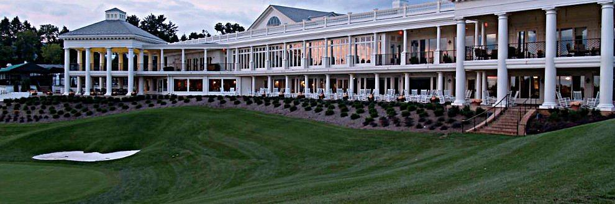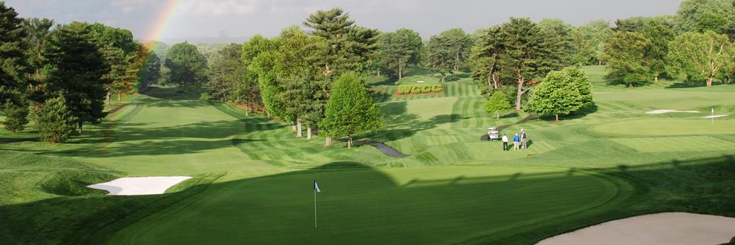
18-holes of Golf for 3 guests at Washington Golf and Country Club with Dr. Christopher Verlach

Donald Ross and William Flynn designed course. Once known as the “Playground of Presidents”, the course offers a unique layout winding through the Washington, DC area. The sloping fairways and undulating greens keep the low handicapper honest, while other sets of tees keep themed to high handicapper coming back for more.
Value: $400 pkg. for 3 or $133 per guest Opening Bid: $175 pkg. or $60 per guest

