Al-Alwani Event for  Muslim-Christian Dialogue | 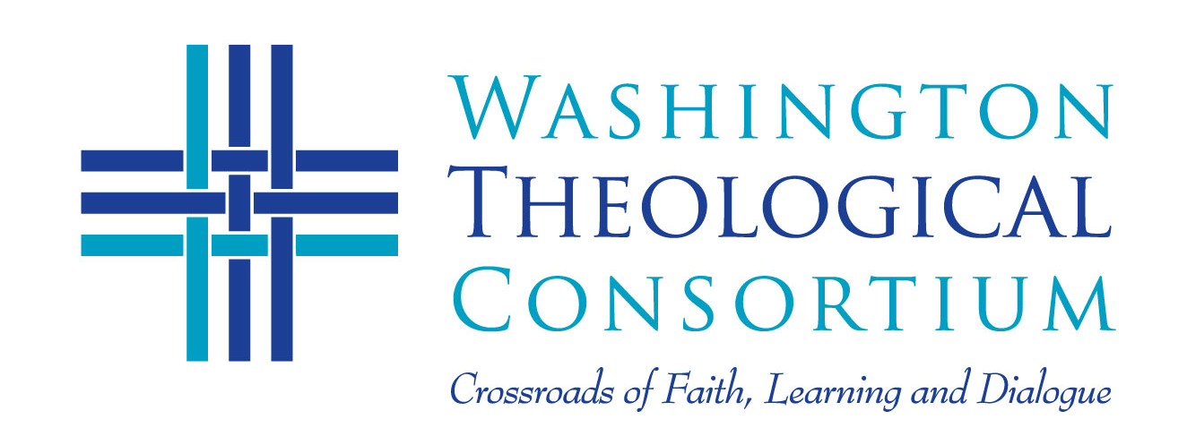
Thursday, March 30  6:00-9:00 pm  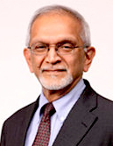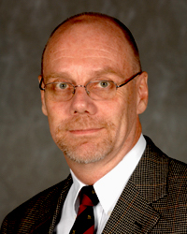  Sachedina Madigan  Two experts in interreligious dialogue and the scholarship of their own religious traditions explore the timely issue of how religions co-exist and thrive in a modern, pluralistic society. Dr. Sachedina and Fr. Madigan will explore resources within Islam and Christianity to address the faithful engagement of religious followers and leaders with other religions in the wider pursuit of contributing to civil society and the common good. | Eighth Annual Taha Al-Alwani Lectures in  Muslim-Christian Dialogue  “Religious Faiths in a Pluralistic Society”  Dr. Abdulaziz Sachedina, Professor and IIIT Chair in  Islamic Studies, George Mason University  Dr. Dan Madigan, SJ, Associate Professor at Georgetown University, and Senior Fellow at the Al-Waleed Center for Muslim-Christian Understanding  Venue: the El-Hibri Foundation, 1420 16th Street NW, DC  A few blocks walk from Dupont Circle Metro station. Parking on nearby Streets or at Colonial Garage,1616 P St NW.  Full reception follows lectures and discussion.  This event made possible by the ongoing support of  the Heritage Trust.  More info: http://washtheocon.org/events/
For more information or To RSVP contact wtc@washtheocon.org or call 202-832-2675

415 Michigan Ave. NE, Suite 105
Washington DC, 20017

Two experts in interreligious dialogue and the scholarship of their own religious traditions explore the timely issue of how religions co-exist and thrive in a modern, pluralistic society. Dr. Sachedina and Fr. Madigan will explore resources within Islam and Christianity to address the faithful engagement of religious followers and leaders with other religions in the wider pursuit of contributing to civil society and the common good.

More info: http://washtheocon.org/events/

