Consortium  Public Events  2015-2016  Ecumenical and Interfaith | 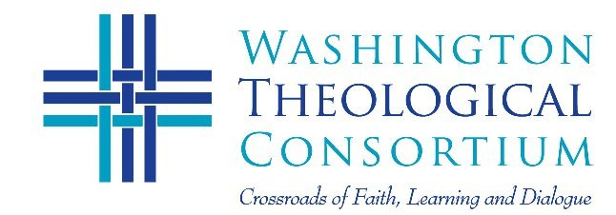
Sunday, November 1  5:30-8:30 pm  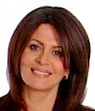 | 15th Annual Tachmindji Event on Interfaith Dialogue  The Security of Religious Communities in the Middle East:  The Importance of Intercommunal Co-existence  Ms. Hind Kabawat  Center for World Religions, Diplomacy, and  Conflict Resolution, George Mason University  Venue: American University School of International Service  4400 Massachusetts Ave. NW, Washington, DC  Lecture, Discussion and Full Reception
Thursday, February 11  5:30-8:30 pm  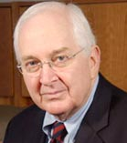 | Service for Christian Unity and 8th Annual Figel Address  The Body Lies Bleeding: The Reformation  and Contemporary Ecclesial Divisions  Dr. Joseph Small  Center for Catholic and Evangelical Theology  Former Director, Office of Theology and Worship, PCUSA  Venue: John Leland Center for Theological Studies  1306 N. Highland Street, Arlington, VA  Prayer Service, Award, Lecture and Full Reception
Tuesday March 8, 2016  6:00-9:00 pm  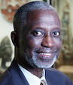 | Sixth Taha Al-Alwani Lectures on Muslim-Christian Dialogue:  African Nationalism and its Impact on Interfaith Dialogue  Dr. Sulayman Nyang  Professor of African Studies, Howard University  Venue: Howard University School of Divinity  2900 Van Ness Street, NW Washington, DC  Lectures, Discussion, Full Reception
April 20, 2016 (tent.)  6:30-9:00 pm | Annual Event for Friends’ of the Consortium  Hold the Date!  For more information, visit: WTC Events
To RSVP contact wtc@washtheocon.org or call 202-832-2675

